NEWTON RIGG EQ CENTRE,

RIDDEN SHOWING SHOW, Bank Hol Mon, 6th May

H&C Qualifiers at this Show

*This Event is being organised by Ellen Jones as an SPARKET EQUESTRIAN EVENT.

*Enquiries: -07787570736 [www.sparketequestrianevents.co.uk](http://www.sparketequestrianevents.co.uk/) for other event details

*ENTRIES £14 per Class. Entries close Friday 3rd May 2024 *ENTER ONLINE AT [www.equoevents.co.uk](http://www.equoevents.co.uk/)

*ENTRIES ON THE DAY £20 per Class for all classes entered on the day.

H&C Judge Classes 16 & 17 & AM Classes – Mrs A Heginbotham, Kendal.

PM Classes – Mrs N Eminson-Smith, Lancs.

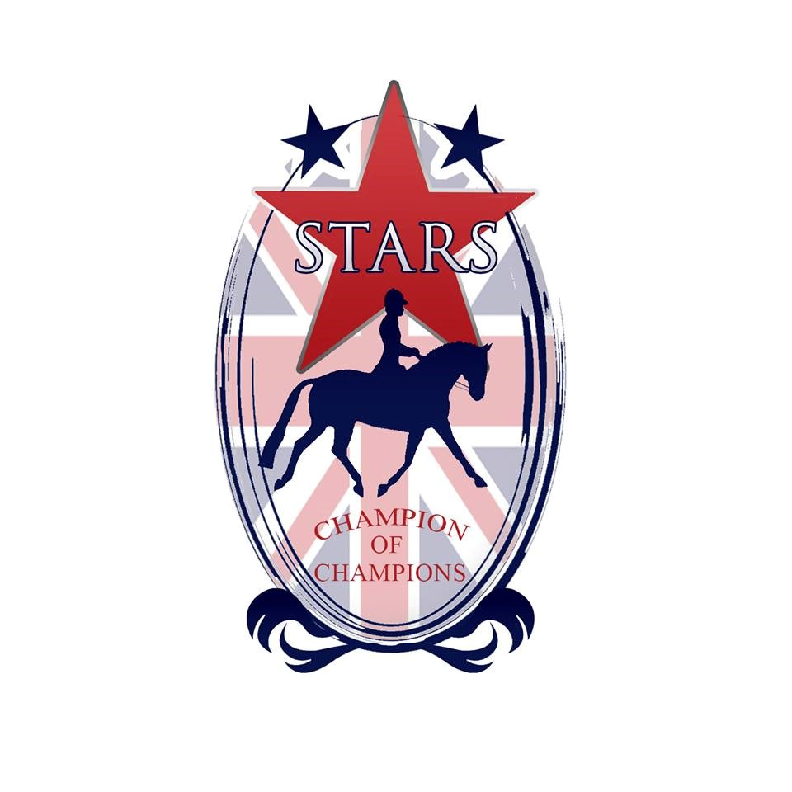

*DIRECTIONS: -**Newton Rigg Equestrian Centre is accessed from the M6 jnction 40. Take the entry to Penrith by the North Lakes Hotel from the junc 40 roundabout. Left at the 1st roundabout into Ind estate. Under railway bridge and then left at next T junction. 1st right signed to Newton Rigg. Take the SECOND north entrance into Newton Rigg, and then first left. Do NOT use the main Newton Rigg entrance.**

**Caledonian Showing Championships**

This show is a qualifier for the Caledonian Showing Championships, which offers competitors the opportunity to compete at a top level Championship Final in Scotland. With a draped main arena, amazing rosettes, special prizes, music, judges from the south and atmospheric Evening Performances, this is the show everyone wants to be part of. This year’s show will be held at

***Highfield @ Howe, near Ladybank, Fife on 18/19/20 October 2024***

Every horse & pony placed 1st in all In hand, Ridden Showing classes (not fun classes) & Working Hunter/Pony classes will qualify to compete in any appropriate class at the Finals. All Champions & Reserves will qualify for the Champion & Reserves Stakes Finals. Qualification will be from placings, no qualification cards will be awarded in the ring, and no qualification can go down the line.

***All qualified horses and ponies will be listed on the Caledonian Showing Championship Show’s website*** [***www.caledonianchampionships.co.uk***](http://www.caledonianchampionships.co.uk/) ***(under construction) or the Puddledub Shows Facebook page***

|  |
| --- |
| Top two placed exhibits in each In Hand and Ridden Class will qualify for The SPARKLE PERFORMANCE SHOW on Sat/Sun 1st & 2nd JUNE 2024.  Qualifying Cards will be available. |

**ROSETTE BUY BACK!!** Should you for whatever reason, return you rosette back to the office on SHOW DAY in AS NEW condition, you will receive £1 for it. This Eco-Friendly Scheme has been introduced for those

competitors who do not wish to keep their rosettes.

**STARS RULES**

- To qualify for STARS, combinations achieve placing Points in any STARS Class highlighted with a red star by the Class. Points can be gained from 5th/6th March Shows up and including the SPARKLE Shows on 16th and 17th September. The STARS Championships is at Aintree on 21st to 24th November 2024.

- The combination of Horse/Pony and Handler must stay the same, with no change of Handler.

- STARS is an amateur Championships, and professionals and Horses or Ponies stabled at a Producer’s yard are not eligible to compete at the STARS Championships, although **everyone, including all professionals are welcome at SPARKET Shows.**

- SPARKET Points will continue to be counted from every SPARKET Show as in previous years. Points will be published after every SPARKET Show in spreadsheet format.

- One combination from each STARS Class will qualify to go through to STARS Championships at Aintree. The qualifying combination will have the highest score from four SPARKET Shows. Competitors may attend more than four Shows, but the best four scores will count. If competitors attend less than four shows, two or three scores will count, **but you MUST attend TWO STARS Shows in ORDER to validate your STARS score.** Double points are awarded at the SPARKLE Championship Show.

**- For Equitation, Riding Club Horse/Pony Club Pony and all Working Hunter competitors, all points from all FOUR Shows on 24th March, 13th April, 28th April and 11th May will count. You do not need to attend all four Shows, but you MUST attend TWO STARS Shows in ORDER to validate your STARS score.**

- In order to participate in either Sparket or STARS Points, SPARKET Membership is needed for each competitor. Membership is £4 until 1st April, then £10 until 1st June. Membership is voluntary, you only need Membership to gain points for STARS, or SPARKET sashes and/or rosettes. SPARKET Membership is available on www.equoevents.co.uk

**- SPARKET Shows are, and always will be open to all, Members and Non Members.**

- Competitors are able to compete at STARS Championships representing two (or more if you have the time!) Clubs or Organisiations.

- Horses and Ponies competing at STARS Championships must be innoculated for Equine Flu with having had the last injection in the previous 6 months, but not within the previous 7 days.

- Stars Championships will be at Aintree 21st to 24th November 2024 inclusive.

**Please see** [**www.starschampionships.co.uk**](http://www.starschampionships.co.uk/) **for all Classes & Rule details**

**RULES**

*All persons entering, competing or otherwise taking part in the above show shall be considered as having read and accepted the following regulations.

*NO CHILD AGED UNDER 3 YEARS ON SHOW DAY MAY COMPETE

*Numbers to be collected from the Secretary on the Show Day

*Riding Hats to standard BSI PAS015 1998, EN13841996, ASTM F1163, SNELLE2001, AS/NZS3838 1998, 2003, SAI GLOBAL must be worn at all times with the chinstrap fastened when mounted

*The Show organisers hold no responsibility for any accident occurring at this show.

*Horse Riding is a riskful sport, and you compete at your own risk.

*Horses must be four years old and over in all the ridden classes.

*Horses/Ponies DO NOT REQUIRE a JMB Height certificate.

*Any suitable bridles may be worn and handles on saddles in the Lead Rein are permitted.

*Spurs can only be worn when riding a horse exceeding 148cms. No Spur Rowels allowed.

*Spurs are not allowed in any Mountain & Moorland Classes.

*Earrings and or visible jewellry is allowed.

*Stallions/Colts MUST be handled by persons aged 14 years and over AT ALL TIMES and must not be left unattended at any time AND MUST WEAR STALLION DISCS.

*Any fall of horse/pony/rider in the class will result in immediate disqualification and they must leave the ring without re-mounting.

*Whips not to exceed 75cm (30”).

*The Judge’s decision is final.

* An exhibitor must not exhibit a horse/pony bred, sold, leased or produced by the Judge, his/her immediate family or his/her employer.

*An exhibitor may not show under a Judge for whom he/she has produced a horse in the same year.

*A rider may not ride in a class judged by someone for whom he/she has ridden in a competition during the current year.

*Competitors may be photographed for Sparket Equestrian Events Publicity in Newspapers, Magazines, Face Book and other media forms on Show Days. By taking part in any Sparket Equestrian Event competitors agree to being photographed for publicity purposes.

*Horse Riding can be a dangerous activity. Newton Rigg EC and/or Sparket Equestrian Events cannot be held responsible for libelous actions at his event by competitors or otherwise.

Ridden Warm Up is available on completion of In Hand Classes.

*PLEASE NOTE NO LUNGING AT ANY TIME in car park or arena.

*Anyone found to be misusing or abusing any person or animal (including horses) will be EVICTED from the premises IMMEDIATELY with no appeal.

*The use of side or running or draw reins is forbidden at any time.

* Any objections must be forwarded to the Secretary with £40 cash and a signed letter of complaint. Should the complaint be upheld the £40 cash will be returned to the objector.

This is a H&C Racehorses (HCR) Series Show for Classes 16 & 17.

You do not need to be a Member of any Showing or Racehorse Organisation to compete in these Classes. The Horse & Country Racehorses (HCR) series is open to Thoroughbreds who have raced, trained or been bred to race. Racing injuries will be ignored providing the horse is sound. Riders must be 14 years plus, ridden horses must be 4 years plus and veterans are 12 years plus. **Judges will not ride** and you will **not be asked to gallop as a ride** but maybe asked to gallop in your individual show.

Members must carry their cards in the ring for signing at qualifying shows and non Members must send their quaifiaction cards (presented by the Judge), fees and regiater with HCR after the qualifying Show. To quaify you should be placed 1st-4th (qualifications may be passed down to 6th place). All handlers/riders **and** horses must becime registered with HCR ahead of the championships and must have qualified in order to compete at the HCR Championship show at Netherton Equestrian, Perth in September 2024.

This Show is affiliated to Equifest, taking place at the ArenaUK, Grantham on the **1st – 4th August 2024.** The **two** highest exhibits not already qualified in each affiliated class will qualify.

**9:00am, – Judge Mrs A Heginbotham, Kendal.**

1. **STARTER Ridden Small Breeds M&M Pony, (Reg & Unreg Pony) Snaffles Only.** Go Round in Walk & Trot. Rider any age, optional canter in individual show, SNAFFLE BITS Only.

2. **STARTER Ridden Large Breeds M&M Pony, (Reg & Unreg Pony) Snaffles Only.** Go Round in Walk & Trot. Rider any age, optional canter in individual show, SNAFFLE BITS Only.

3. **Novice Ridden Small Breeds M&M, snaffles only.** Registered ponies only.

4. **Novice Ridden Large Breeds M&M, snaffles only.** Registered ponies only.

5. **Amateur Ridden M&M.** Registered M&M pony ridden & owned by any age of rider who doesnt receive income from Training, schooling or breaking ponies & doesnt receive income from giving riding lessons and/or training. Ponies can be Novice or Open and the rider doesnt have to be the same person. Rider can be unrelated to Pony’s owner. NB. Both Rider and Owner need to be Amateurs as defined above. Any suitable bit. Registered ponies only.

6. **Equifest JUNIOR RIDDEN MOUNTAIN & MOORLAND**

Mares and geldings, 4 years old & over, registered in the respective pure bred Stud Books of Connemara, Dales, Dartmoor, Exmoor, Fell, Highland New Forest, Shetland and Welsh Section A, B, C & D. Riders of Small Breeds not to have attained their 14th birthday before 1st January in the current year. Riders of Large Breeds not to have attained their 18th birthday before 1st January in the current year.

**Equifest OPEN RIDDEN MOUNTAIN & MOORLAND**

Open to Mountain & Moorland ponies registered with their respective Pure Bred Societies, mare or gelding, 4 years old and over. Rider any age. To be split as follows -

7) Dartmoor, Exmoor, Shetland, Welsh A, B, - **This is a STARS points Class.**

8) Connemara, Dales, Fell, Highland, New Forest, Welsh C and D. - **This is a STARS points Class.**

**CHAMPIONSHIP, Classes 1 to 8, 1st & 2nd PRIZE WINNERS eligible**

**11:00 am approx, Judge - Mrs A Heginbotham, Kendal.**

9. **Best Turned Out - This is a STARS points Class.**

Open to any age rider, horse or pony. LR ponies eligible for this Class. To be judged as follows -

30% tack, 30% Pony/Horse, 30% rider, 10% overall impression. This is a STARS points Class.

10. **STARTER Ridden Novice Pony, Any type, Go round in Walk and Trot only,** Rider any age, optional canter in individual show, SNAFFLE BITS Only.

11. **RIDDEN SHOW PONIES (Mixed Height) - This is a STARS points Class. No rider age limit.**

Open Show Pony, mare or gelding, 4 yrs old & over, not exceeding 148cm.

12.  **RIDDEN SHOW HUNTER PONIES (Mixed Height) - This is a STARS points Class. No rider age limit.** Show Hunter Pony, mare or gelding, 4 yrs old & over, not exceeding 153cms.

13. **Equifest OPEN RIDDEN PART BREDS**

Stallion, mare or gelding, 4 years old and over. Exhibits in this section must be registered in the Part Bred section of their respective Breed Society. Horses and ponies will not be ridden at the final. Riders any age.

14, **Equifest OPEN SMALL/LARGE Hunter or Riding Type INTERMEDIATE not exc 158cm.** Open Intermediate Show Riding Type, mare or gelding, 4 years old and over, exceeding 146cms but not exceeding 158cm. Open Intermediate Show Hunter Type, mare or gelding, 4 years old and over, exceeding 148cms but not exceeding 158cms. Riders not to have attained their 25th birthday before 1st January in the current year.

**CHAMPIONSHIP, Classes 9 to 14, 1st & 2nd PRIZE WINNERS eligible**

**11:30 am approx, Judge - Mrs A Heginbotham, Kendal.**

**15. WARM UP Ridden Ex Racer, Go round in Walk and Trot only,** canter in individual Show. Rider 15 year or over, Ex Racers entering Classes 2, 3, 5 are welcome to enter this Class as a warm up to familiarise themselves with the Ring and its surroundings. This Class is non qualifying.

**16. HCR Ridden Ex Racehorse; horses 4 years old and over, any sex, riders 14 years and over.**

No Membership needed to enter/exhibit in this Class. No registration needed to compete in this Class. £16 entry

**17. HCR In hand Ex Racehorse; horses any age and sex, handlers to be 14 years and over.**

No Membership needed to enter/exhibit in this Class. £16 entry

**18. OPEN RE-TRAINED RACE HORSE**

Thoroughbred mare or gelding, 4 yrs old and over, any height. This is a STARS points Class. NB. In order to compete at STARS at Aintree, Horses must be RoR registered.

**EX RACER CHAMPIONSHIP, Classes 15 to 18, 1st & 2nd PRIZE WINNERS eligible**

**2:00pm approx, – Judge - N Eminson, Lancs.**

19. **STARTER Ridden Novice Horse/Pony, Any Type, Go round in Walk and Trot only,** Rider any age, optional canter in individual show, SNAFFLE BITS Only.

20. **EQUIFEST OPEN RIDDEN VETERAN HORSE/PONY aged 15 years to 19 years.** Open to horses and ponies of all types including Lead Rein.

This Class is a STARS Points Class for the STARS Champion of Champions.

21. **EQUIFEST RIDDEN VETERAN HORSE/PONY aged 20 years and over.** Open to horses and ponies of all types including Lead Rein.

This Class is a STARS Points Class for the STARS Champion of Champions.

22. **EQUIFEST OPEN RIDDEN HUNTER & EQUIFEST OPEN SMALL HUNTER**

Open Ridden Hunter, mare or gelding, 4 years old and over, exceeding 148cm. Riders any age. Open Small Hunter, mare or gelding, 4 years and over, exceeding 148cm but not exceeding158cm. Riders any age.

This Class is a STARS Points Class for the STARS Champion of Champions.

**23. EQUIFEST OPEN RIDDEN HACKS**

Open Show Hacks, mare or gelding, 4 years old & over over, exceeding 148cm, but not exceeding 160cms. Riders any age.

**24. EQUIFEST OPEN RIDING HORSES**

Open Riding Horse, mare or gelding, 4 years old and over, any height. Riders any age.

**25. Ridden Plaited Show Horse exceeding 148cm.** Riders any age. This is a STARS Points class.

26. **EQUIFEST OPEN RIDDEN COBS & MAXI COBS**

Open Ridden Cob, mare or gelding, 4 years old & over, exc148cms but not exceeding 155cms. Open Maxi Cob, mare or gelding, 4 years old and over, exceeding 155cms. To be shown hogged and trimmed. Riders any age. This is a STARS points Class.

**CHAMPIONSHIP, Classes 19 to 27, 1st & 2nd PRIZE WINNERS eligible**

**10:30 approx, Judge – N Eminson, Lancs.**

28. **TINY TOTS Lead Rein Pony, plaited/M&M/coloured, under 122 cm,**

Riders not to have attained their 6th birthday before 1st Jan in current year.

29. **LEAD REIN SHOW PONY/SHOW HUNTER PONY as below -** To be led by an attendant and shown in a snaffle bridle. Lead rein to be attached to the noseband only.

**PLEASE NOTE ONE SET OF ROSETTES FOR THIS CLASS.** This is a STARS points Class.

Leading Rein Show/Show Hunter Pony, mare or gelding, 4 years old & over over not exceeding 128cms. Riders not to have attained their 10th birthday before 1st January in the current year.

30. **EQUIFEST OPEN MOUNTAIN & MOORLAND LEAD REIN** Open to Mountain & Moorland ponies, registered with their respective Pure Bred Societies of Dartmoor, Exmoor, New Forest, Shetland and Welsh A or B. Mare or gelding, 4 years old and over, not exceeding 128cms. Riders not to have attained their 9th birthday before 1st January in the current year. To be led by an attendant and shown in a Snaffle Bridle, the lead rein to be attached to the noseband only. This is a STARS points Class.

31. **Home Produced Plaited or M&M Lead Rein Pony.**

Pony and rider must meet the age & height criteria for one of the above Lead Rein Classes.

Pony must not have been stabled in the yard of a professional Professional Producer or Trainer Yard since 1st Feb of the current year. Rider must not have ridden a pony for a Producer/Trainer since 1st Feb in current year. Pony must not be owned by anyone who has taken payment for Training or Producing ponies since 1st Jan of current year.

**CHAMPIONSHIP, 1st & 2nd  PRIZE WINNERS from Classes 28 to 31 eligible**

**11:30pm approx, – Judge – N Eminson, Lancs. Classes 32, 33, 34 are all STARS points Classes.**

32. Tiny Tots Handler, not to have attained their 8th Birthday as of 1st Jan of current year, No Colts or Stallions and all ponies to be 4 yrs plus. Young Handlers must wear a conforming Hard Hat.

33. Junior Handler, to have attained their 8th Birthday but not their 12th Birthday as of 1st Jan of current year, No Colts or Stallions and all ponies to be 4 yrs plus. Young Handlers must wear a conforming Hard Hat.

34. Young Handler, to have attained their 12th Birthday but not their 18th Birthday as of 1st Jan of current year, No Colts or Stallions and all ponies to be 4 yrs plus. Young Handlers must wear a conforming Hard Hat.

**CHAMPIONSHIP, 1st  & 2nd PRIZE WINNERS from Classes 32 to 34 eligible**

**12:30pm approx, Judge – N Eminson, Lancs.**

35. **TINY TOTS First Pony, M&M/plaited/traditional/coloured, under 128cms,**

Riders not to have attained their 9th birthday before 1st Jan in current year.

27. **Ridden Critical Rare/Foreign/Heavy Horse Breeds.** Open to all Foreign and Heavy Horse Breeds and Cleveland Bay, Dales, Dartmoor, Eriskay, Exmoor, Hackney, Fell, Highland, New Forest Pure Bred Breeds registered in their Breed Society. Also, Incorporating Equifest Class for 2024 as follows -

**BRHHS EVERSLEY RIDDEN HEAVY HORSES**

Open to horses, 4 years old and over that are registered in the main British Stud Books of the Shire, Clydesdale, Suffolk or Percheron Society at the time of qualification and must be entered in the name and ownership they are registered. Qualification to be awarded no lower than third place if the winning horse has already qualified. At shows where there is no Ride Judge a stand/individual show will be required. Riders will be required to give a short individual show at walk, trot & canter or set show lasting approximately 2 minutes. Change of rein and lengthened strides in trot and canter must be shown. Rein back, (optional) stand still and obedience to the leg. Horses should leave the ring at a walk or trot. Entries will not be asked to jump. Horses will not be ridden by the Judge at Sparket Shows.

TWO highest placed Shire, Clydesdale, Suffolk or Percheron horses not already qualified will receive Equifest qualification subject to current Equifest current rules.

36. **COMBINED FIRST RIDDEN SHOW PONY and FIRST RIDDEN SHOW HUNTER PONY. PLEASE NOTE ONE SET OF ROSETTES FOR THIS CLASS.**

A) First Ridden Show Pony or Show Hunter Pony, mare or gelding, 4 years old & over over not exceeding 128cms. Riders not to have attained their 12th birthday before 1st January in the current year. This is a STARS points Class.

37. **EQUIFEST MOUNTAIN & MOORLAND FIRST RIDDEN** Open to Mountain & Moorland ponies, registered with their respective Pure Bred Societies of Dartmoor, Exmoor, New Forest, Shetland and Welsh A or B. Mare or gelding, 4 years old and over, not exceeding 128cms. Riders not to have attained their 12th birthday before 1st January in the current year. To be shown in any suitable bridle. This is a STARS points Class.

38. **Home Produced Plaited or M&M First Ridden Pony.** Pony and rider must meet the age & height criteria for one of the above First Ridden Classes. Pony must not have been stabled in the yard of a professional Professional Producer or Trainer Yard since 1st Feb of the current year. Rider must not have ridden a pony for a Producer/Trainer since 1st Feb in current year. Pony must not be owned by anyone who has taken payment for Training or Producing ponies since 1st Jan of current year.

**MINI CHAMPIONSHIP, CLASSES 35 to 38, 1st & 2nd PRIZE WINNERS eligible.**

**not B4 3:30pm, - Judge – N Eminson, Lancs.**

39. **STARTER Ridden Novice Pony/Horse, Any type, Go round in Walk and Trot only,** Rider any age, optional canter in individual show, SNAFFLE BITS Only.

40. Ridden Plaited Coloured Horse or Pony, Any Height. This is a STARS points Class.

41. Ridden Hogged Coloured Cob, Any Height.

42. Ridden Native Coloured Cob

43. Ridden Traditional Coloured Cob, Any Height.

44. Ridden Traditional Solid Colour Cob, Any Height, Full feather and mane & tail.

45. Ridden Native/Hogged/Traditional Coloured Horse/Pony. This is a STARS points class.

**46. EQUIFEST RIDDEN PIEBALD/SKEWBALD.** Open ridden Piebald/Skewbaldstallion, mare or gelding, 4 yrs old & over. Riders any age. The first three places will also qualify for the BSPA Championship subject to their show rules & conditions.

**CHAMPIONSHIP, Classes 39 to 46, 1st  & 2nd PRIZE WINNERS eligible**

*This Event is being organised by Ellen Jones as an SPARKET EQUESTRIAN EVENT.

*Enquiries: -07787570736 [www.sparketequestrianevents.co.uk](http://www.sparketequestrianevents.co.uk/) for other event details

*ENTRIES £14 per Class. (£16 for H&C Classes) Entries close Friday 3rd May 2024

*ENTRIES ON THE DAY £6 extra for all classes entered on the day.

*ENTER ONLINE AT [www.equoevents.co.uk](http://www.equoevents.co.uk/)

**2024 SPARKET Show & Clinic Dates as follows -**

Sat March 2nd – In Hand Show

Sun March 3rd – Ridden Show

Sun March 24th – WHP & Performance Nord Vue

Sat April 6th – Ridden Show

Sat April 13th – WHP & Performance Nord Vue

Sun April 14th - In Hand Show

Sun April 28th – WHP & Performance Nord Vue

Sun May 5th – In Hand Show

BH Mon May 6th – B Hol Mon RoR etc. Show

Sat May 11th – WHP & Performance Nord Vue

Sat May 25th - Nord Vue Last Minute SPARKLE

Ridden Qualification Show

Sun May 26th - Nord Vue Last Minute SPARKLE

In Hand Qualification Show

Sat June 1st IN HAND SPARKLE

Sun June 2nd RIDDEN SPARKLE

Sat Sept 28th – In Hand Show

Sun Sept 29th - Ridden Show

Sat Oct 26th – In Hand Show

Sun Oct 27th – Ridden Show

Sun 3rd Nov – Richard Telford Clinic