**\*DIRECTIONS: - Newton Rigg is accessed from junc 40 of the M6. Then take the A592 towards Penrith past the Environment Agency on your left, take next left into Haweswater Rd for a mile approx until you get to a roundabout, and then left over the M6, and then right onto Newton Road. Newton Rigg Eq Centre is over a mile further on, on the Right Hand side. DO NOT USE NEWTON RIGG MAIN ENTRANCE. Take the 2nd turn into Newton Rigg to the Equestrian Facilities. Postcode is CA11 0AH. Use junction 40 of the M6. DO NOT USE Junc 41 as there is a LOW BRIDGE.**

NEWTON RIGG EQUESTRIAN CENTRE,

IN HAND SHOW, SUN, 5th May 2024

All Day Judge – Mr C Turner, Lancs.

*This Event is being organised by Ellen Jones as an SPARKET EQUESTRIAN EVENT.

*Enquiries: -07787570736 [www.sparketequestrianevents.co.uk](http://www.sparketequestrianevents.co.uk/) for other event details

*PRE ENTRIES £15 per Class close Thursday 2nd May 2024, timetable out Friday 2nd May

*ON THE DAY ENTRIES £20.. *ENTER ONLINE AT [www.equoevents.co.uk](http://www.equoevents.co.uk/)





|  |
| --- |
| All 1st, 2nd & 3rd placed exhibits in each Class qualify for 2023 SPARKLE CHAMPIONSHIPS on 1st & 2nd June 2024.  www.sparketequestrianevents.co.uk |

**Caledonian Showing Championships**

This show is a qualifier for the Caledonian Showing Championships, which offers competitors the opportunity to compete at a top level Championship Final in Scotland. With a draped main arena, amazing rosettes, special prizes, music, judges from the south and atmospheric Evening Performances, this is the show everyone wants to be part of at ***Highfield @ Howe, Ladybank, Fife 18/19/20 October 2024*** *Every horse & pony placed 1st in all Inhand, Ridden Showing classes (not fun classes) & Working Hunter/Pony classes will qualify to compete in any appropriate class at the Finals. All Champions & Reserves will qualify for the Champion & Reserves Stakes Finals. Qualification will be from placings, no qualification cards will be awarded in the ring, and no qualification can go down the line. All qualified horses and ponies will be listed on the Caledonian Showing Championship Show’s website www.caledonianchampionships.webs.com*

**This Show is affilliated to EQUIFEST, which takes place at ARENAUK, Grantham, Lincs, on the 1st to 4th August 2024. The TWO highest exhibits not already qualified in each affiliated Class will qualify.**

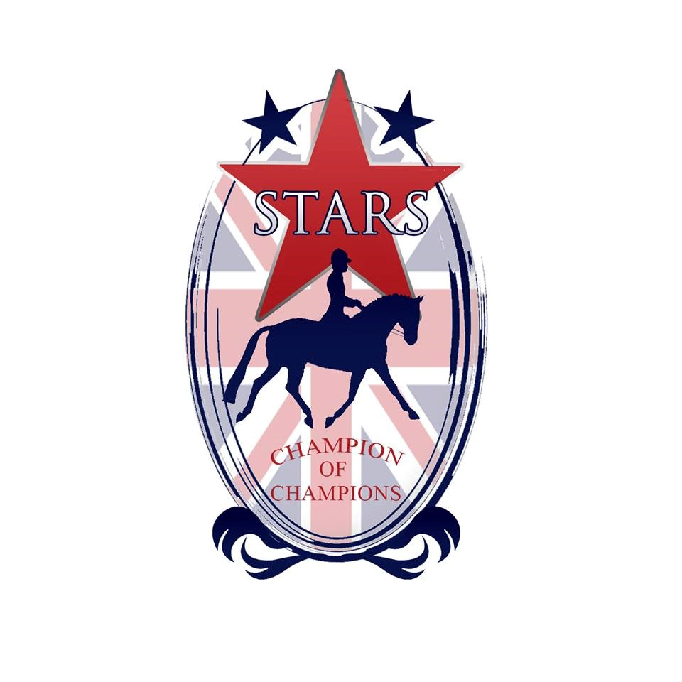

**STARS RULES**

- To qualify for STARS, combinations achieve STARS Points in any STARS Class highlighted with a red star by the Class. Points can be gained from 1st/2nd March Shows to SPARKLE on 1st/2nd June which is the last STARS Points Show of 2024.

- The combination of Horse/Pony and Handler must stay the same, with no change of Handler.

- STARS is an amateur Championships, and professionals and Horses or Ponies stabled at a Producer’s yard after 1st March 2023 are not eligible to compete at the STARS Championships, although everyone, including all professionals are welcome at SPARKET Shows.

- Semi professionals, that is, any competitor who shows 2 or more animals for other people, regardless if payment is taken or not, is classed by STARS as a semi-professional, and is NOT eligible to compete at STARS.

- No STARS rider or handler is allowed to show an animal for a professional producer in 2023.

- SPARKET Points will continue to be counted from every SPARKET Show as in previous years. Points will be published after every SPARKET Show in spreadsheet format.

- One combination from each STARS Class will qualify to go through to STARS Championships at Aintree. The qualifying combination will have the highest score from four SPARKET Shows. Competitors may attend more than four Shows, but the best four scores will count. Competitors must attend at least two Sparket STAR Shows in order for scores to count. Double points are awarded at the SPARKLE Championship Show.

- Please note that in order to fit in with STARS Class wordings, some Classes have altered. Please check your Class. Young Handler is now split into three age sections which is definitely a good thing. Solid Coloured feathered Cobs are shown in hand with Hogged Cobs.

- From this year, in order to participate in either Sparket or STARS Points, SPARKET Membership is needed for each competitor. Membership is £4 until 1st April, then £10 until 1st June.

Membership is voluntary, you only need Membership to gain points for STARS, or SPARKET sashes and/or rosettes. SPARKET Membership is available on www.equoevents.co.uk

**- SPARKET Shows are, and always will be open to all, Members and Non Members.**

- Competitors are able to compete at STARS Championships representing two (or more if you have the time!) Clubs or Organisiations.

- Horses and Ponies competing at STARS Championships must be innoculated for Equine Flu with having had the last injection in the previous 6 months, but not within the previous 7 days.

- Stars Championships will be at Aintree in November.

**Please see** [**www.starschampionships.co.uk**](http://www.starschampionships.co.uk/) **for all Classes & Rule details**

**9:00am START, Judge – Mr C Turner**

1. In Hand BEST TURNED OUT, Plaited or Coloured or Non &M. 4 yrs & over.

2. In Hand BEST CONDITION, Plaited or Coloured or Non M&M. 4 yrs & over.

3. In Hand BEST TURNED OUT, Plaited or Coloured or Non M&M. Youngstock.

4. In Hand BEST CONDITION, Plaited or Coloured or Non M&M. Youngstock.

**CHAMPIONSHIP, 1st  & 2nd PRIZE WINNERS from Classes 1 to 4 eligible**

**Not B4 9:30am, Judge, Mr C Turner**

5. In Hand Rescue Pony/Horse. Any Age/Type/Height. Open to RSPCA/Private/other organisation Rescue Horses & Ponies. You will be asked about your Horse/Pony’s Rescue history in your individual show.

6. In Hand Plaited Pony, ANY AGE, not exc 148cm. STARS POINTS CLASS

7. In Hand Plaited Horse, ANY AGE, exc 148cm. STARS POINTS CLASS

8. In Hand Critical/Rare/Foreign/Heavy Horse Breeds. Open to Arab, Freisian, American Quarter Horse, Falabella, Fjord, Haflinger, Dales, Cleveland Bay, etc. Breed to be stated on entry under “notes”.

9. In Hand Thoroughbred/Ex Racer/Been Race Trained.

10. In Hand Veteran Horse/Pony aged 15 years and over. Combined Age Class. Open to horses and ponies of any breed, height and type. This is a STARS POINTS CLASS

11. In Hand Cob (inc Traditional Coloured & Solid). STARS POINTS CLASS

12. Youngstock, 3 yrs & under, Any type. STARS POINTS CLASS

13. Ridden Rescue Pony/Horse. Any Age/Type/Height. Open to RSPCA/Private/other organisation Rescue Horses & Ponies. You will be asked about your Horse/Pony’s Rescue history in your individual show.

**CHAMPIONSHIP, 1st  & 2nd PRIZE WINNERS from Classes 5 to 13 eligible**

**Not B4 10:15am, Judge – Mr C Turner**

14. In Hand Coloured Youngstock. 1, 2, 3 years old. Any height/type

15. In Hand Traditional Solid Colour Feathered Cob or Hogged Cob. Any height or age.

16. In Hand Native Coloured Horse/Pony. Any height/age.

17. In Hand Traditional Coloured Horse/Pony. Any height/age.

18. In Hand Plaited Coloured Horse/Pony. Any height/age.

19. In Hand Coloured Pony not exc 143cm. Any type/age. STARS POINTS CLASS

20. In Hand Coloured Horse exc 143cm. Any type/age. STARS POINTS CLASS

21. **EQUIFEST In Hand Piebald/Skewbald** Open In Hand Piebald/Skewbald stallion, mare or gelding, any age. The first three places will also qualify for the BSPA Championship subject to their show rules and conditions.

**CHAMPIONSHIP, 1st  & 2nd PRIZE WINNERS from Classes 14 to 21 eligible**

**Not B4 midday, Judge – Mr C Turner**

22. In Hand M&M BEST TURNED OUT, 4 yrs old & over.

23. In Hand M&M BEST CONDITION, 4 yrs old & over.

24. In Hand M&M BEST TURNED OUT, Youngstock.

25. In Hand M&M BEST CONDITION, Youngstock.

**CHAMPIONSHIP, 1st  & 2nd PRIZE WINNERS from Classes 22 to 25 eligible**

26. In Hand Fell or Dales Pony, aged 4 years and over.

27. In Hand Fell or Dales Pony Youngstock, 1, 2 or 3 years

28. In Hand Mountain & Moorland Yearling (Any Breed)

29. In Hand Mountain & Moorland 2 year old (Any Breed)

30. In Hand Mountain & Moorland 3 year old (Any Breed)

31. In Hand Unregistered/Part bred M&M, any age. To be shown unplaited or plaited.

32. Equifest Open In Hand Small Mountain & Moorland, Stallion, Mare or Gelding, any age, (Ex/Dart/Shet/Welsh A&B) STARS POINTS CLASS

33. Equifest Open In Hand Large Mountain & Moorland, Stallion, Mare or Gelding, any age, (Fell, Dales, High, Conn, NF, Welsh C & D) STARS POINTS CLASS

**CHAMPIONSHIP, 1st  & 2nd PRIZE WINNERS from Classes 26 to 33 eligible**

**2024 Dates as follows -**

Sat April 6th – Ridden Show

Sat April 13th – WHP & Performance Nord Vue

Sun April 14th - In Hand Show

Sun April 28th – WHP & Performance Nord Vue

Sun May 5th – In Hand Show

BH Mon May 6th – B Hol Mon RoR etc. Show

Sat May 11th – WHP & Performance Nord Vue

Sat May 25th - Nord Vue Last Minute SPARKLE

Ridden Qualification Show

Sun May 26th - Nord Vue Last Minute SPARKLE

In Hand Qualification Show

Sat June 1st IN HAND SPARKLE

Sun June 2nd RIDDEN SPARKLE

Sat Sept 28th – In Hand Show

Sun Sept 29th - Ridden Show

Sat Oct 26th – In Hand Show

Sun Oct 27th – Ridden Show

Sun 3rd Nov – Richard Telford Clinic

Shows highlighted GREEN are Performance STARS points

Shows highlighted yellow are In Hand/Ridden STARS points

**RULES**

*All persons entering, competing or otherwise taking part in the above show shall be considered as having read and accepted the following regulations.

*NO CHILD AGED UNDER 3 YEARS ON SHOW DAY MAY COMPETE

*Numbers to be collected from the Secretary on the Show Day

*Riding Hats to standard BSI PAS015 1998, EN13841996, ASTM F1163, SNELLE2001, AS/NZS3838 1998, 2003, SAI GLOBAL must be worn at all times with the chinstrap fastened when mounted

*The Show organisers hold no responsibility for any accident occurring at this show.

*Horse Riding is a riskful sport, and you compete at your own risk.

*Horses must be four years old and over in all the ridden classes.

*Horses/Ponies DO NOT REQUIRE a JMB Height certificate.

*Any suitable bridles may be worn and handles on saddles in the Lead Rein are permitted.

*Spurs can only be worn when riding a horse exceeding 148cms. No Spur Rowels allowed.

*Spurs are not allowed in any Mountain & Moorland Classes and/or Veteran Classes and/or Junior Classes.

*Stallions/Colts MUST be handled by persons aged 14 years and over AT ALL TIMES and must not be left unattended at any time STALLIONS MUST WEAR STALLION DISCS.

*Any fall of horse/pony/rider in the class will result in immediate disqualification and they must leave the ring without re-mounting.

*Whips not to exceed 75cm (30”).

*The Judge’s decision is final.

* An exhibitor must not exhibit a horse/pony bred, sold, leased or produced by the Judge, his/her immediate family or his/her employer.

*An exhibitor may not show under a Judge for whom he/she has produced a horse/pony in the same year.

*A rider may not ride in a class judged by someone for whom he/she has ridden in a competition during the current year.

*Competitors may be photographed for Sparket Equestrian Events Publicity in Newspapers, Magazines, Face Book and other media forms on Show Days. By taking part in any Sparket Equestrian Event competitors agree to being photographed for publicity purposes.

*Horse Riding can be a dangerous activity. Nord Vue/Newton Rigg EC and/or Sparket Equestrian Events cannot be held responsible for libelous actions at his event by competitors or otherwise.

*PLEASE NOTE NO LUNGING AT ANY TIME in car park or arena.

*Anyone found to be misusing or abusing any person or animal (including horses) will be EVICTED from the premises IMMEDIATELY with no appeal.

*The use of side or running or draw reins is forbidden at any time.

*Please note that all Horses/Ponies at this event MUST be vaccinated for Equine Flu on a 12 month basis, having had the first 2 injections of the course.

*No horse/pony to compete within 7 days of a Flu innoculation.

* Any objections must be forwarded to the Secretary with £40 cash and a signed letter of complaint. Should the complaint be upheld the £40 cash will be returned to the objector.

*This Event is being organised by Ellen Jones as an SPARKET EQUESTRIAN EVENT.

*Enquiries: -07787570736 [www.sparketequestrianevents.co.uk](http://www.sparketequestrianevents.co.uk/) for other event details

*PRE ENTRIES £15 per Class close Thursday 2nd May 2024

*ON THE DAY ENTRIES £20.. *ENTER ONLINE AT [www.equoevents.co.uk](http://www.equoevents.co.uk/)



